Table of Contents
Table of Contents 1
1. Executive Summry 1
2. Dataset Overview 1
3. Data Preparation 1
4. Exploratory Data Analysis 1
5. EDA Visualizations 1
6. Time-Based Feature Engineering 1
7. Stationarity Analysis 1
8. ACF and PACF Analysis 1
9. Train / Validation / Test Strategy 1
10. Baseline Models 1
11. Forecasting Models 1
12. Model Comparison — Validation 1
13. Hyperparameter Tuning 1
14. Backtesting 1
15. Final Test Evaluation 1
16. Final Actual vs Predicted Visualizations 1
17. Product-Level Accuracy 1
18. Product-Level Actual vs Predicted Plots 1
19. Top Products by Historical Demand 1
20. Final 6-Month Forecast 1
21. Final 12-Month Forecast 1
22. Monthly Forecast 1
23. Forecast Confidence Intervals 1
24. Highest and Lowest Forecast-Demand Months 1
25. Inventory Planning 1
26. Business Recommendations 1
27. Project Limitations 1
28. Recommended Future Improvements 1
29. Final Conclusion 1
30. Deliverables Checklist 1
31. Generated Project Files 1

1. Executive Summary

Objective
The objective of this project is to forecast future product demand for approximately 6–12 months using the Favorita Grocery Sales Forecasting dataset.
The forecasts are intended to support:
- Inventory planning
- Supply-chain planning
- Replenishment decisions
- Seasonal procurement
- Demand-risk assessment
The main aggregate forecasting series was constructed by aggregating sales by date across stores and products.
Historical Period: 2013-01-01 to 2017-08-15
Main Forecast Horizon (6 months): 2017-08-16 to 2018-02-13
Main Forecast Horizon (12 months): 2017-08-16 to 2018-08-15
Final Forecast Model: Tuned Seasonal ARIMA — SARIMA(2,1,2)(1,0,1,7)

Important Evaluation Finding
The tuned SARIMA model produced the lowest MAE on the final test period, while the 7-day Seasonal Naive model produced lower MAPE and higher directional accuracy. Therefore, no single model dominates every evaluation metric.

2. Dataset Overview
Favorita Grocery Sales Forecasting dataset from Kaggle.

Main Datasets Used
- train.csv
- items.csv
- stores.csv
- holidays_events.csv
Additional Favorita datasets were available for extended feature engineering.

Dataset Scale
Category | Metric | Value
Product Catalog | Products | 4,100
Product Catalog | Product Families | 33
Product Catalog | Product Classes | 337
Stores | Stores | 54
Stores | Cities | 22
Stores | States | 16
Stores | Store Types | 5
Stores | Store Clusters | 17

The extracted training CSV was approximately 5 GB, so chunk-based processing was used instead of loading the complete file into memory.
3. Data Preparation
The original sales data was recorded approximately at the Date × Store × Product level. The aggregate forecasting dataset was created as Date → Total Unit Sales, producing a daily time series covering the historical period.

Missing Calendar Dates
Four dates were absent from the raw aggregate sales series:
- 2013-12-25
- 2014-12-25
- 2015-12-25
- 2016-12-25
These corresponded to Christmas (“Navidad”) national holidays in the holiday dataset. For the aggregate forecasting series, these dates were represented as zero recorded demand and retained with a structural_missing indicator.

Negative Sales
The raw data contained negative unit_sales observations, consistent with returns in the competition data.
Negative raw observations identified: 7,795
These were not blindly removed before aggregation.

4. Exploratory Data Analysis

Long-Term Trend
Average daily demand increased substantially across the historical period.

Monthly Seasonality
December showed the highest average daily sales among the months.

Weekly Seasonality
Demand varied considerably by day of week.
Highest average daily demand: Sunday
Lowest average daily demand: Thursday

Holiday Effect
Holiday and non-holiday demand showed different average sales levels.

Outliers
Five aggregate daily observations were flagged using the IQR method. These observations were retained because unusually high demand can represent genuine business behavior rather than bad data.

5. EDA Visualizations

Daily Sales Trend
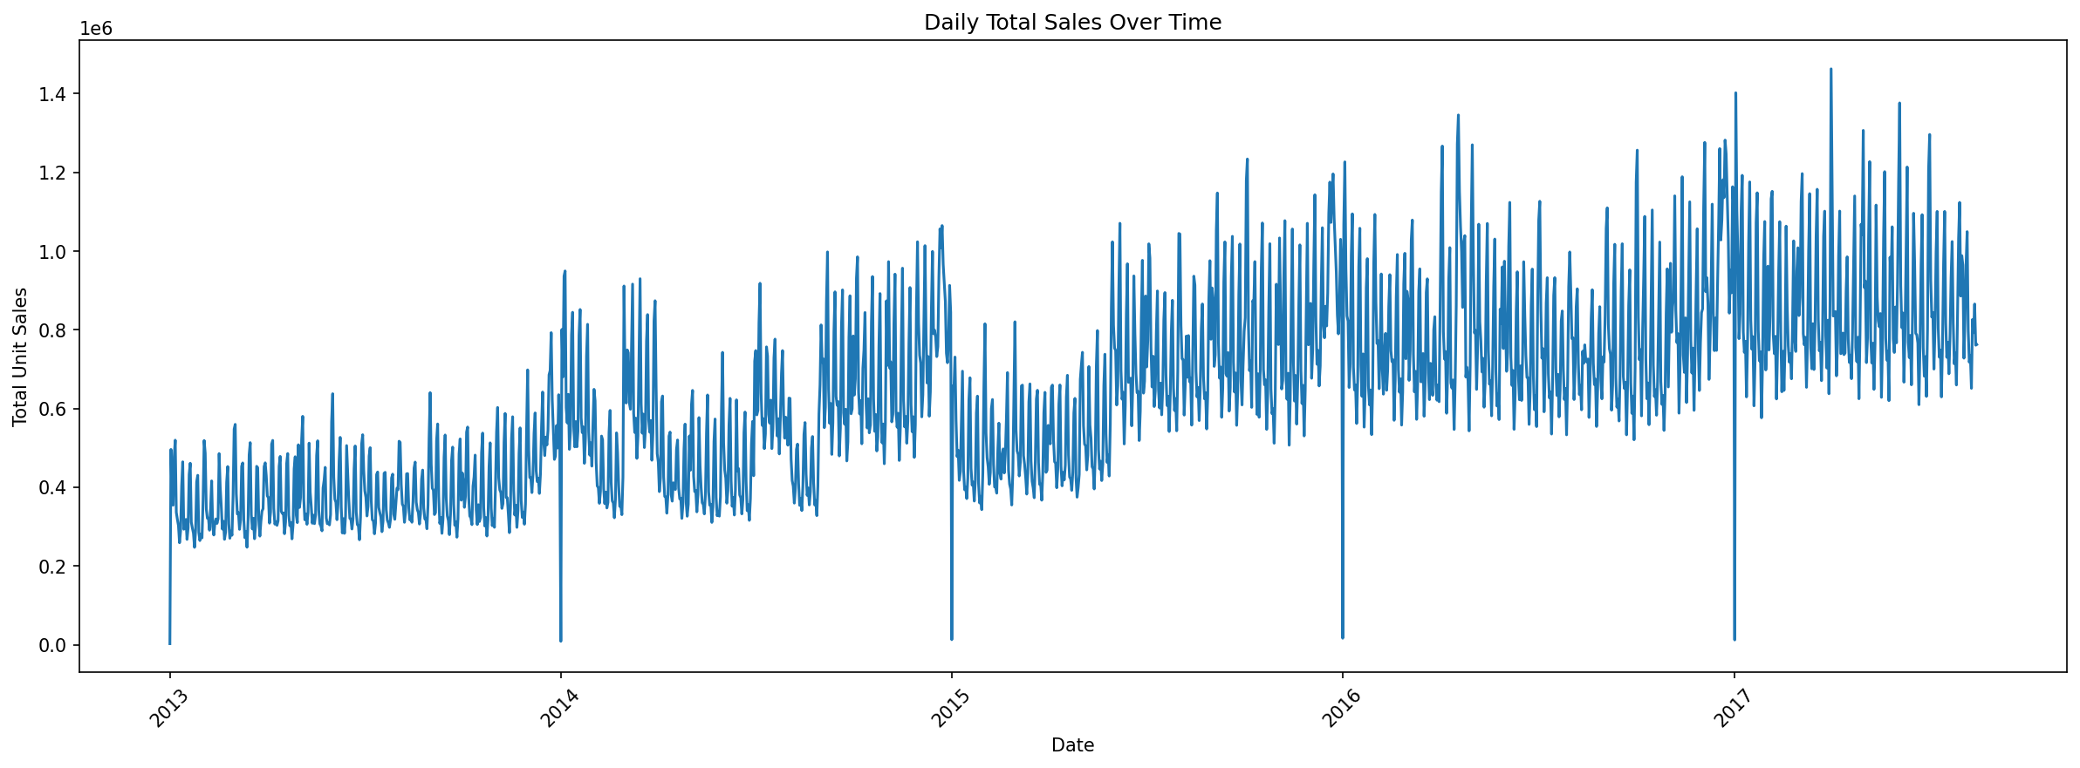
Daily Total Sales Over Time

Daily Sales Distribution
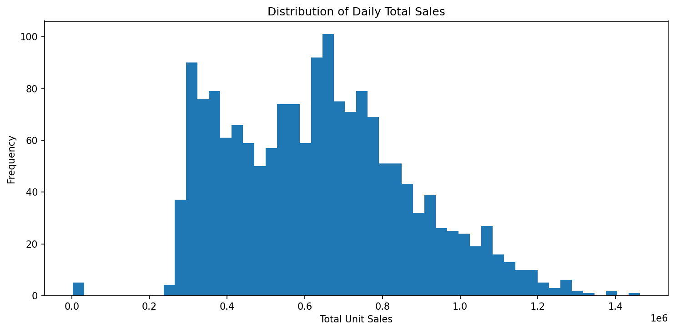
Distribution of Daily Total Sales

Weekly Sales Trend
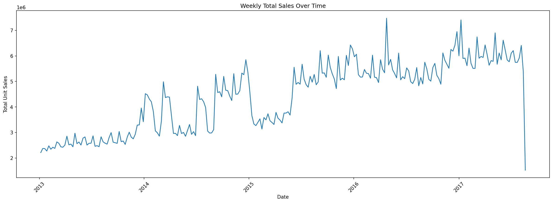
Weekly Total Sales Over Time

Monthly Sales Trend
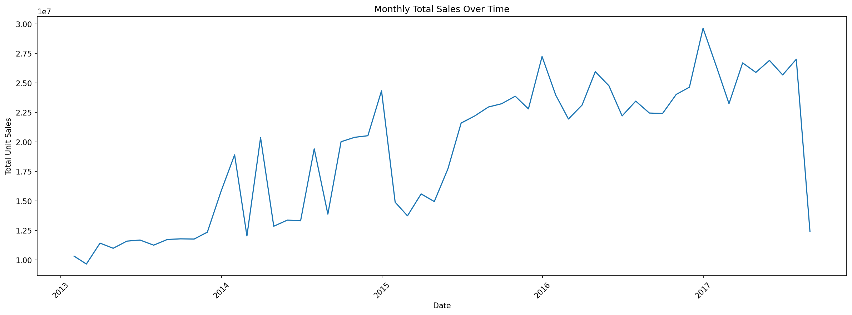
Monthly Total Sales Over Time

Average Sales by Month
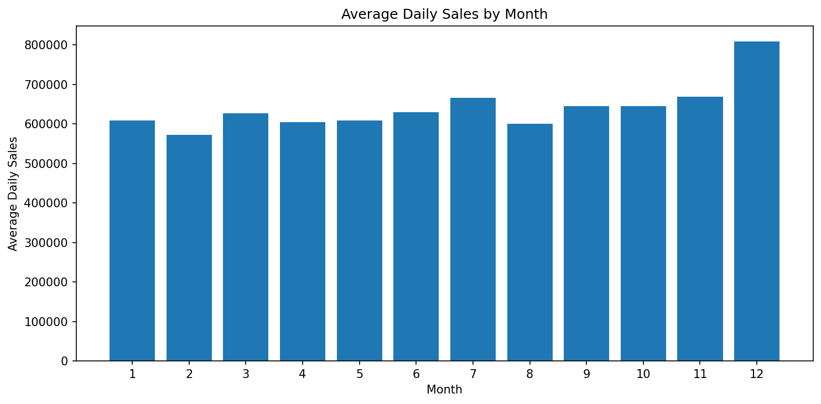
Average Daily Sales by Month

Average Sales by Day of Week
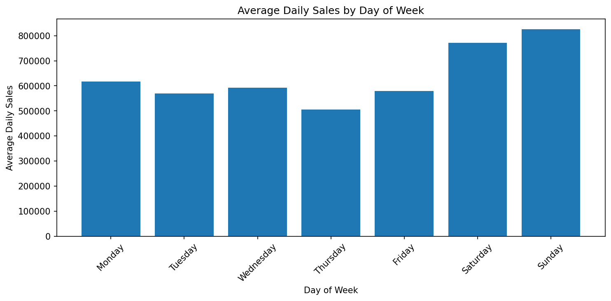
Average Daily Sales by Day of Week

Year × Month Seasonality
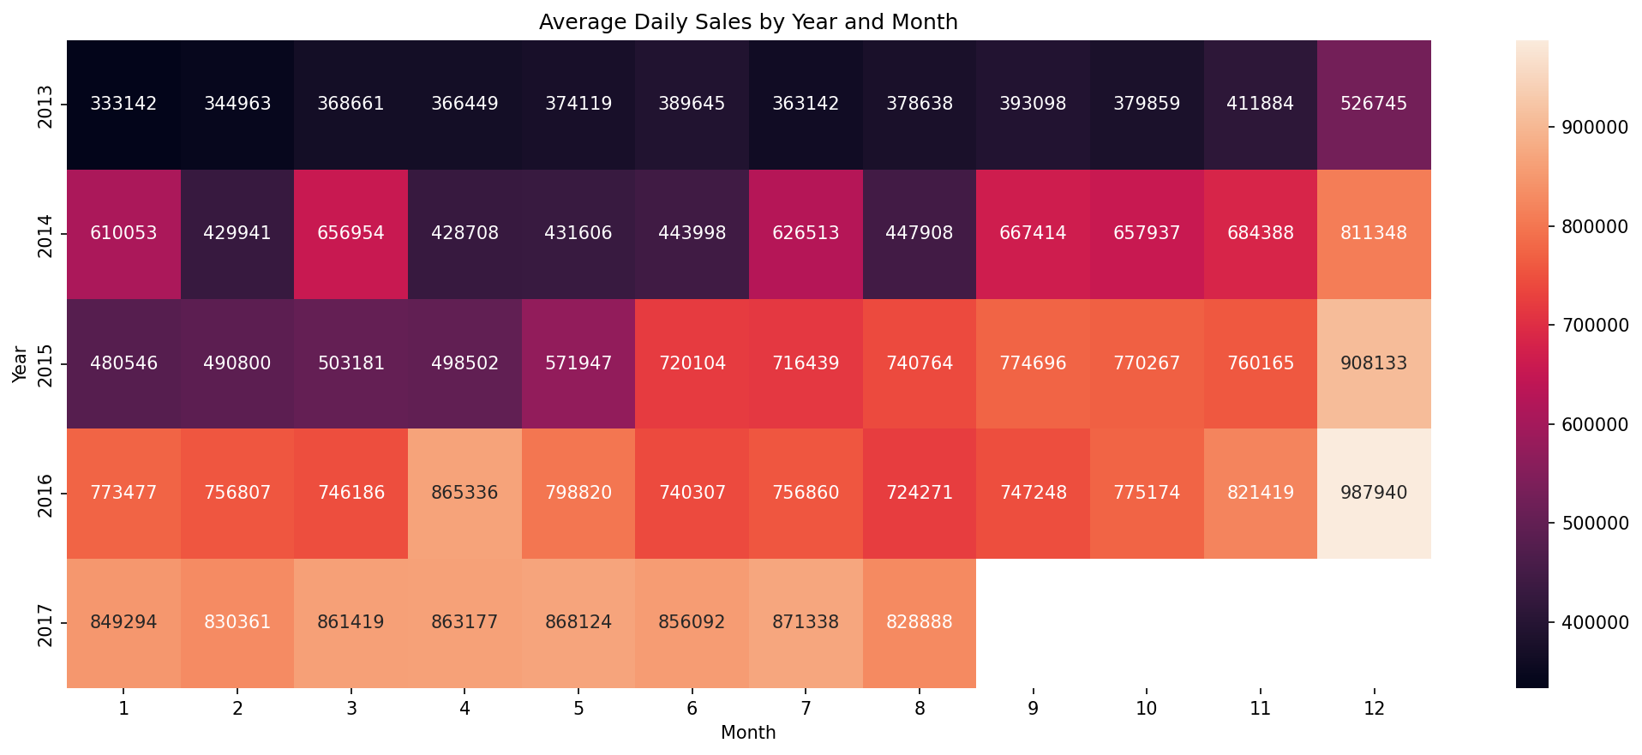
Year by Month Sales Heatmap

Holiday vs Non-Holiday Demand
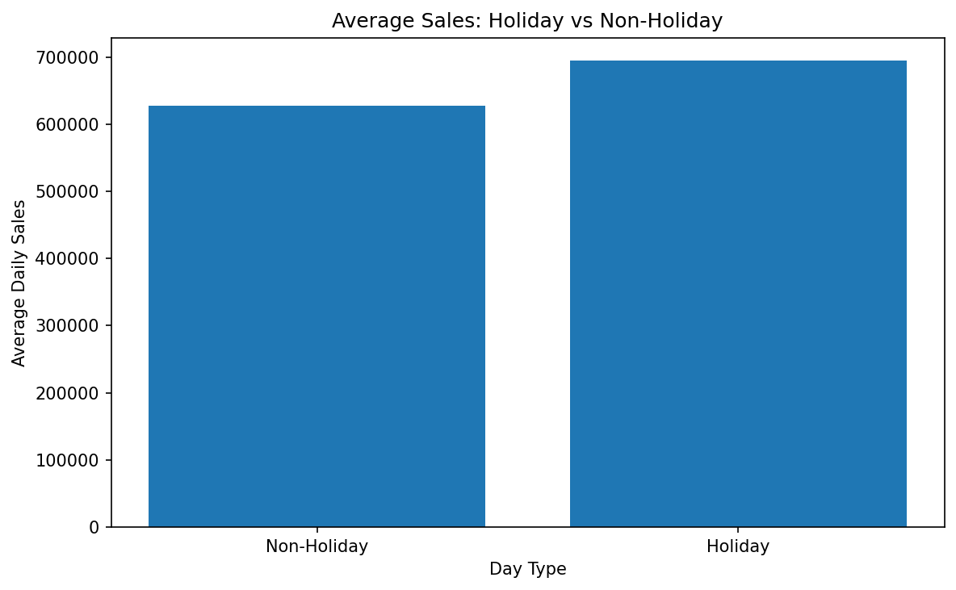
Holiday vs Non-Holiday Sales

6. Time-Based Feature Engineering
The final feature dataset included:
- Year
- Month
- Quarter
- Day
- Day of week
- Day name
- Weekend indicator
- Holiday indicator
- Holiday count
- Holiday type
- Holiday description
- Holiday locale
The dataset was saved as: daily_sales_features.csv
7. Stationarity Analysis The Augmented Dickey-Fuller (ADF) test was performed.
Series | ADF Statistic | p-value | Conclusion
Original Series | -2.5721 | 0.09891 | Non-stationary (5% level)
First Difference | -11.3137 | 1.22e-20 | Stationary
7-Day Difference | -12.7575 | 8.28e-24 | Stationary

8. ACF and PACF Analysis
The first-differenced ACF showed strong autocorrelation at lag 7.
ACF at lag 7 ≈ 0.646 — strong evidence of weekly seasonality. The forecasting models therefore used a seasonal period of 7 days.

ACF Plot
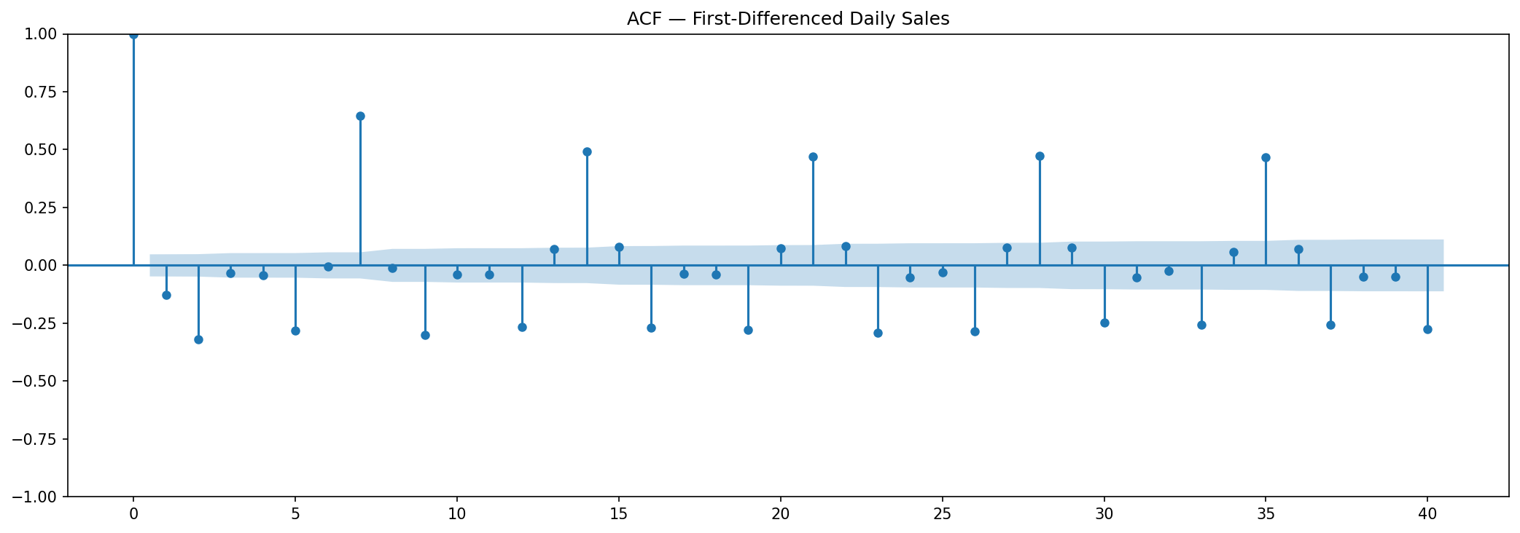
ACF Plot

PACF Plot
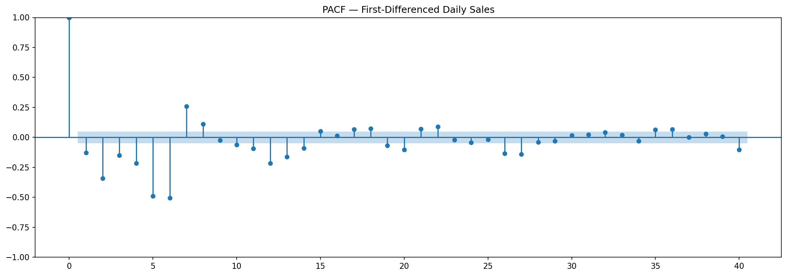
PACF Plot

Seasonal ACF Plot
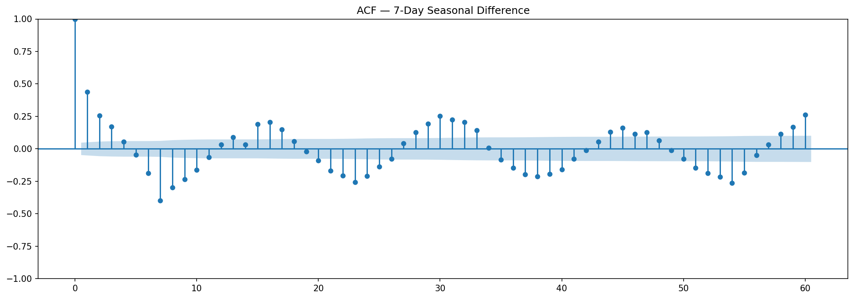
Seasonal ACF Plot

Seasonal PACF Plot
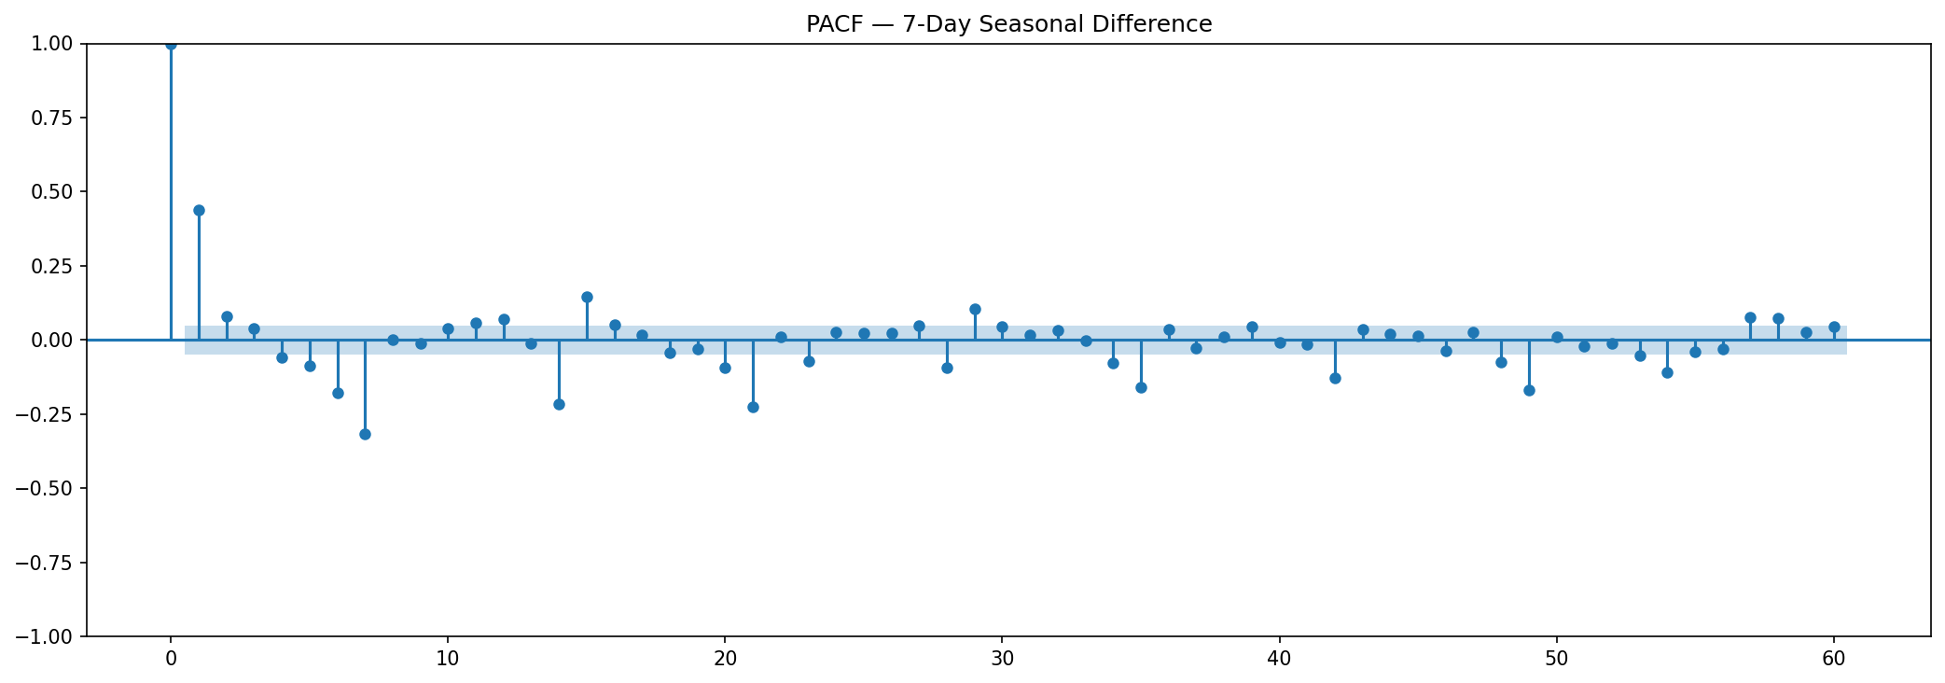
Seasonal PACF Plot

9. Train / Validation / Test Strategy
The data was split chronologically. No random shuffling was used — this preserves the time-dependent nature of forecasting and avoids future-information leakage.
Split | Period | Observations
Training | 2013-01-01 to 2016-02-15 | 1,141
Validation | 2016-02-16 to 2016-08-15 | 182
Test | 2016-08-16 to 2017-08-15 | 365

10. Baseline Models

Naive
The next value is based on the latest observed value.

Seasonal Naive
The forecast uses the value from 7 days earlier. The Seasonal Naive baseline was particularly important because weekly seasonality was detected in the EDA and ACF analysis.
11. Forecasting Models
The following models were implemented:
- Naive
- Seasonal Naive
- ARIMA
- SARIMA
- Exponential Smoothing
- Prophet
- LSTM

Evaluation metrics:
- MAE
- RMSE
- MAPE
- Directional Accuracy

12. Model Comparison — Validation
Model | MAE | RMSE | MAPE (%) | Dir. Accuracy (%)
SARIMA(1,1,1)(1,0,1,7) | 81,682.2 | 122,035 | 9.834 | 82.873
Exponential Smoothing | 88,279.9 | 119,269 | 11.178 | 80.110
Seasonal Naive (7-day) | 116,352 | 165,784 | 14.426 | 80.663
Prophet | 124,195 | 152,770 | 16.662 | 76.243
Naive | 130,411 | 168,915 | 16.084 | 60.773
ARIMA(2,1,2) | 132,584 | 166,812 | 16.677 | 60.773
LSTM | 154,281 | 177,664 | 21.172 | 59.669

Validation Interpretation
The initial SARIMA model — SARIMA(1,1,1)(1,0,1,7) — produced the lowest validation MAE at 81,682.163. The Exponential Smoothing model was also competitive. The LSTM model produced higher error on this aggregate daily series than the statistical seasonal models.

13. Hyperparameter Tuning
A SARIMA grid search containing 36 parameter combinations was performed.
Selected tuned model: SARIMA(2,1,2)(1,0,1,7)

Tuned Validation Metrics
Metric | Result
MAE | 81,434.785
RMSE | 121,683.450
MAPE | 9.800%
Directional Accuracy | 82.873%

The tuning improvement in MAE was approximately 0.3%.
14. Backtesting
Expanding-window backtesting was performed using:
- 90-day forecast horizon
- 4 historical folds
- Tuned SARIMA
- 7-day Seasonal Naive

Pooled Backtesting Results
Model | MAE | RMSE | MAPE (%) | Dir. Accuracy (%)
SARIMA | 182,449 | 246,082 | 44.217 | 69.638
Seasonal Naive | 87,580.3 | 129,100 | 12.976 | 79.387

Backtesting Interpretation
The Seasonal Naive model was more consistent across the four historical folds. Tuned SARIMA performed better on 2 of 4 folds. This demonstrates that model performance changes depending on the historical period.

Backtesting MAE by Fold
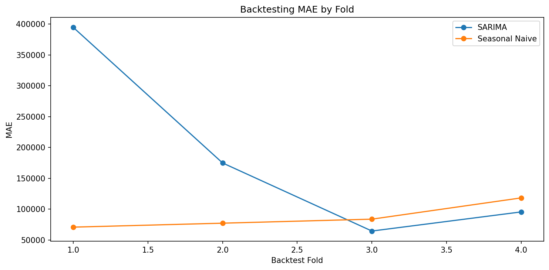
Backtesting MAE by Fold

Backtesting Example
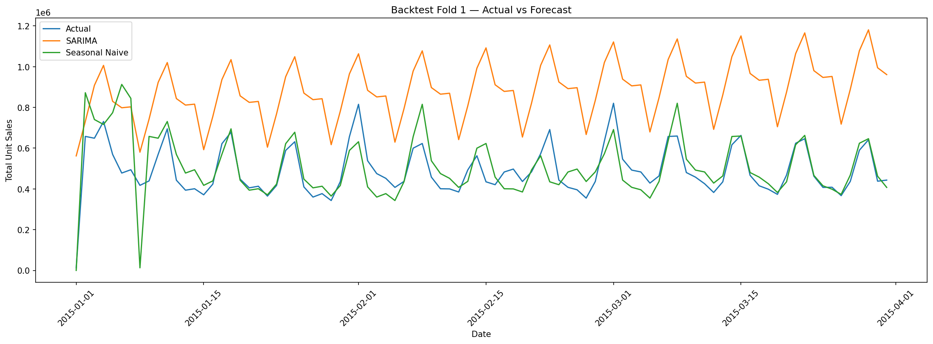
Backtest Fold 1 — Actual vs Forecast

15. Final Test Evaluation
Final test period: 2016-08-16 to 2017-08-15
Model | MAE | RMSE | MAPE (%) | Dir. Accuracy (%) | MAPE Zero Excl.
Tuned SARIMA | 102,727 | 159,076 | 31.356 | 79.945 | 1
Seasonal Naive | 107,351 | 167,140 | 12.055 | 81.319 | 1

Test Interpretation
Tuned SARIMA — MAE: 102,726.907 | RMSE: 159,075.850 | MAPE: 31.356% | Directional Accuracy: 79.945%
Seasonal Naive — MAE: 107,350.712 | RMSE: 167,139.970 | MAPE: 12.055% | Directional Accuracy: 81.319%
The tuned SARIMA model achieved a lower MAE on the final test period, while Seasonal Naive achieved lower MAPE and higher directional accuracy. This difference should be explicitly considered when interpreting forecast accuracy for business use.

16. Final Actual vs Predicted Visualizations

Validation — Seasonal Naive
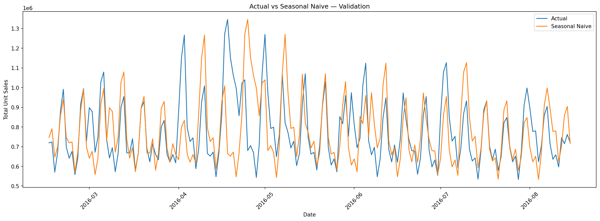
Actual vs Seasonal Naive — Validation

Validation — ARIMA
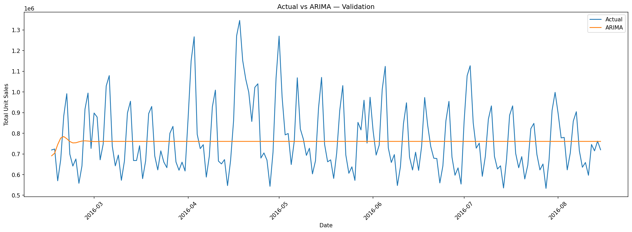
Actual vs ARIMA — Validation

Validation — SARIMA
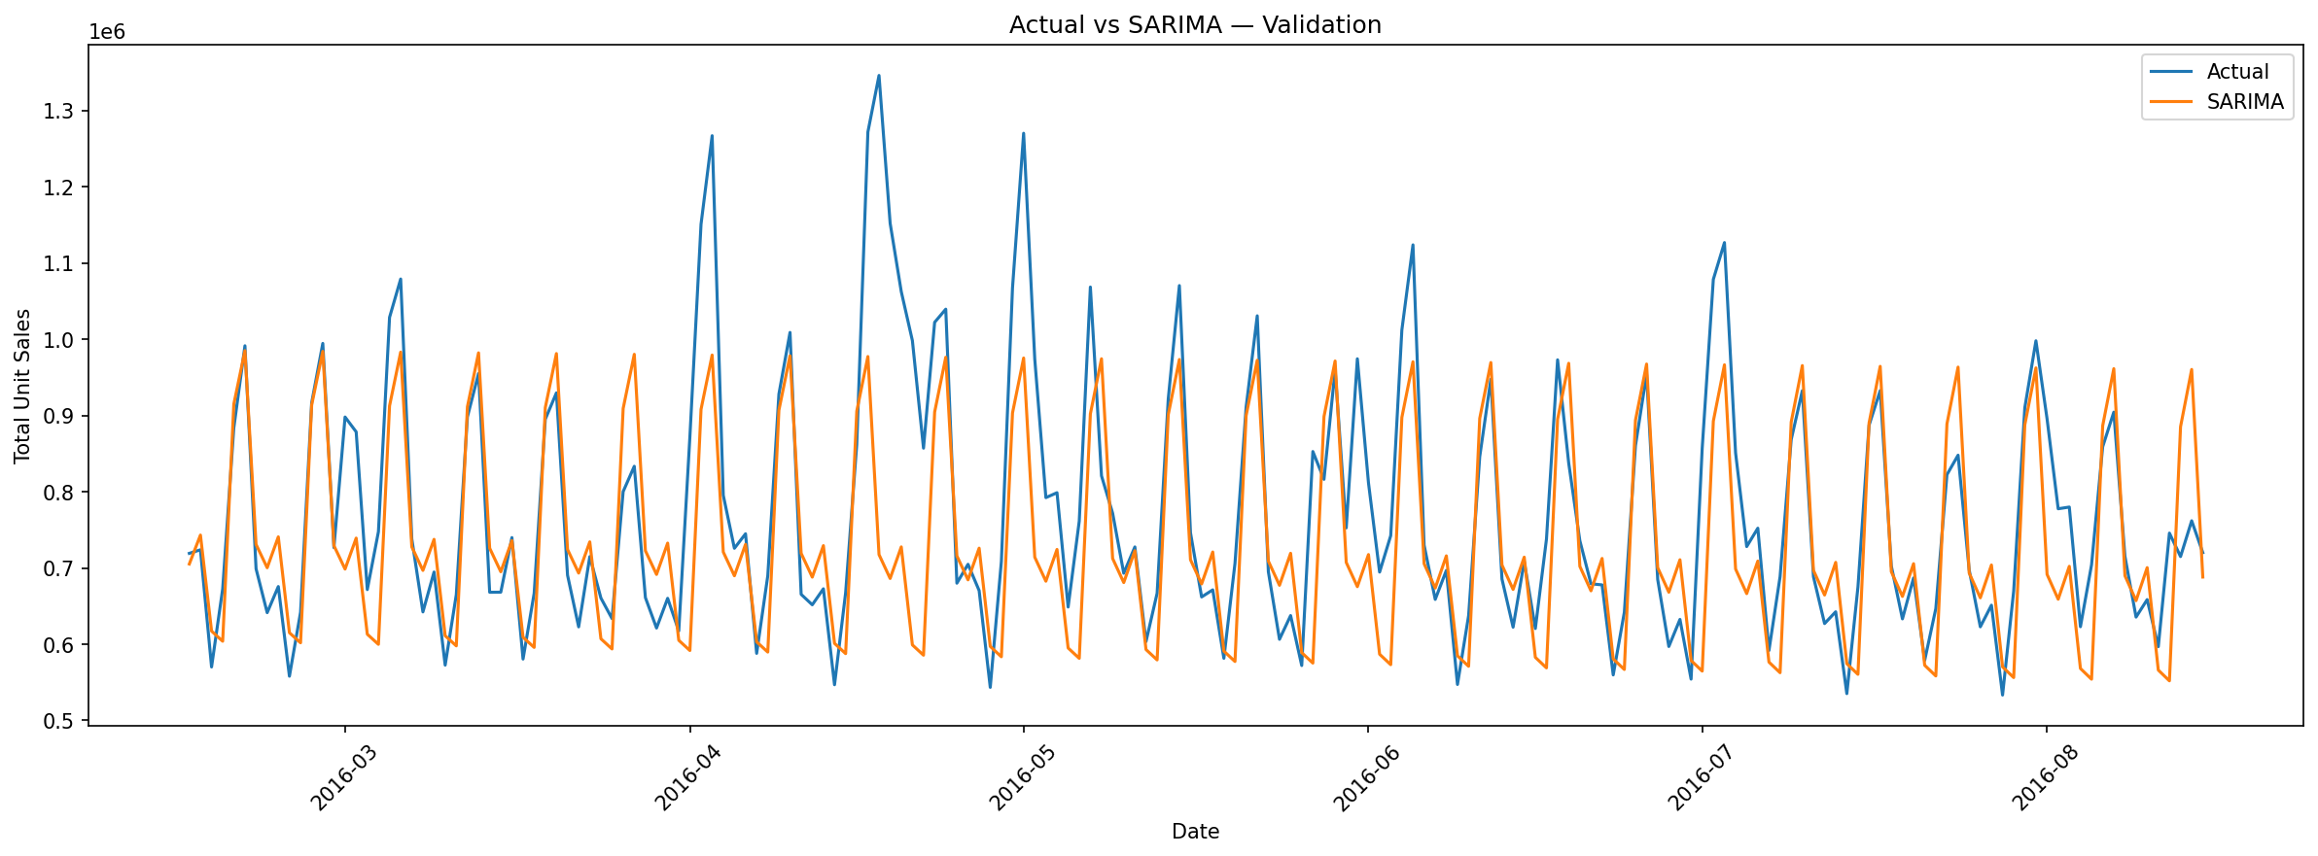
Actual vs SARIMA — Validation

Validation — Exponential Smoothing
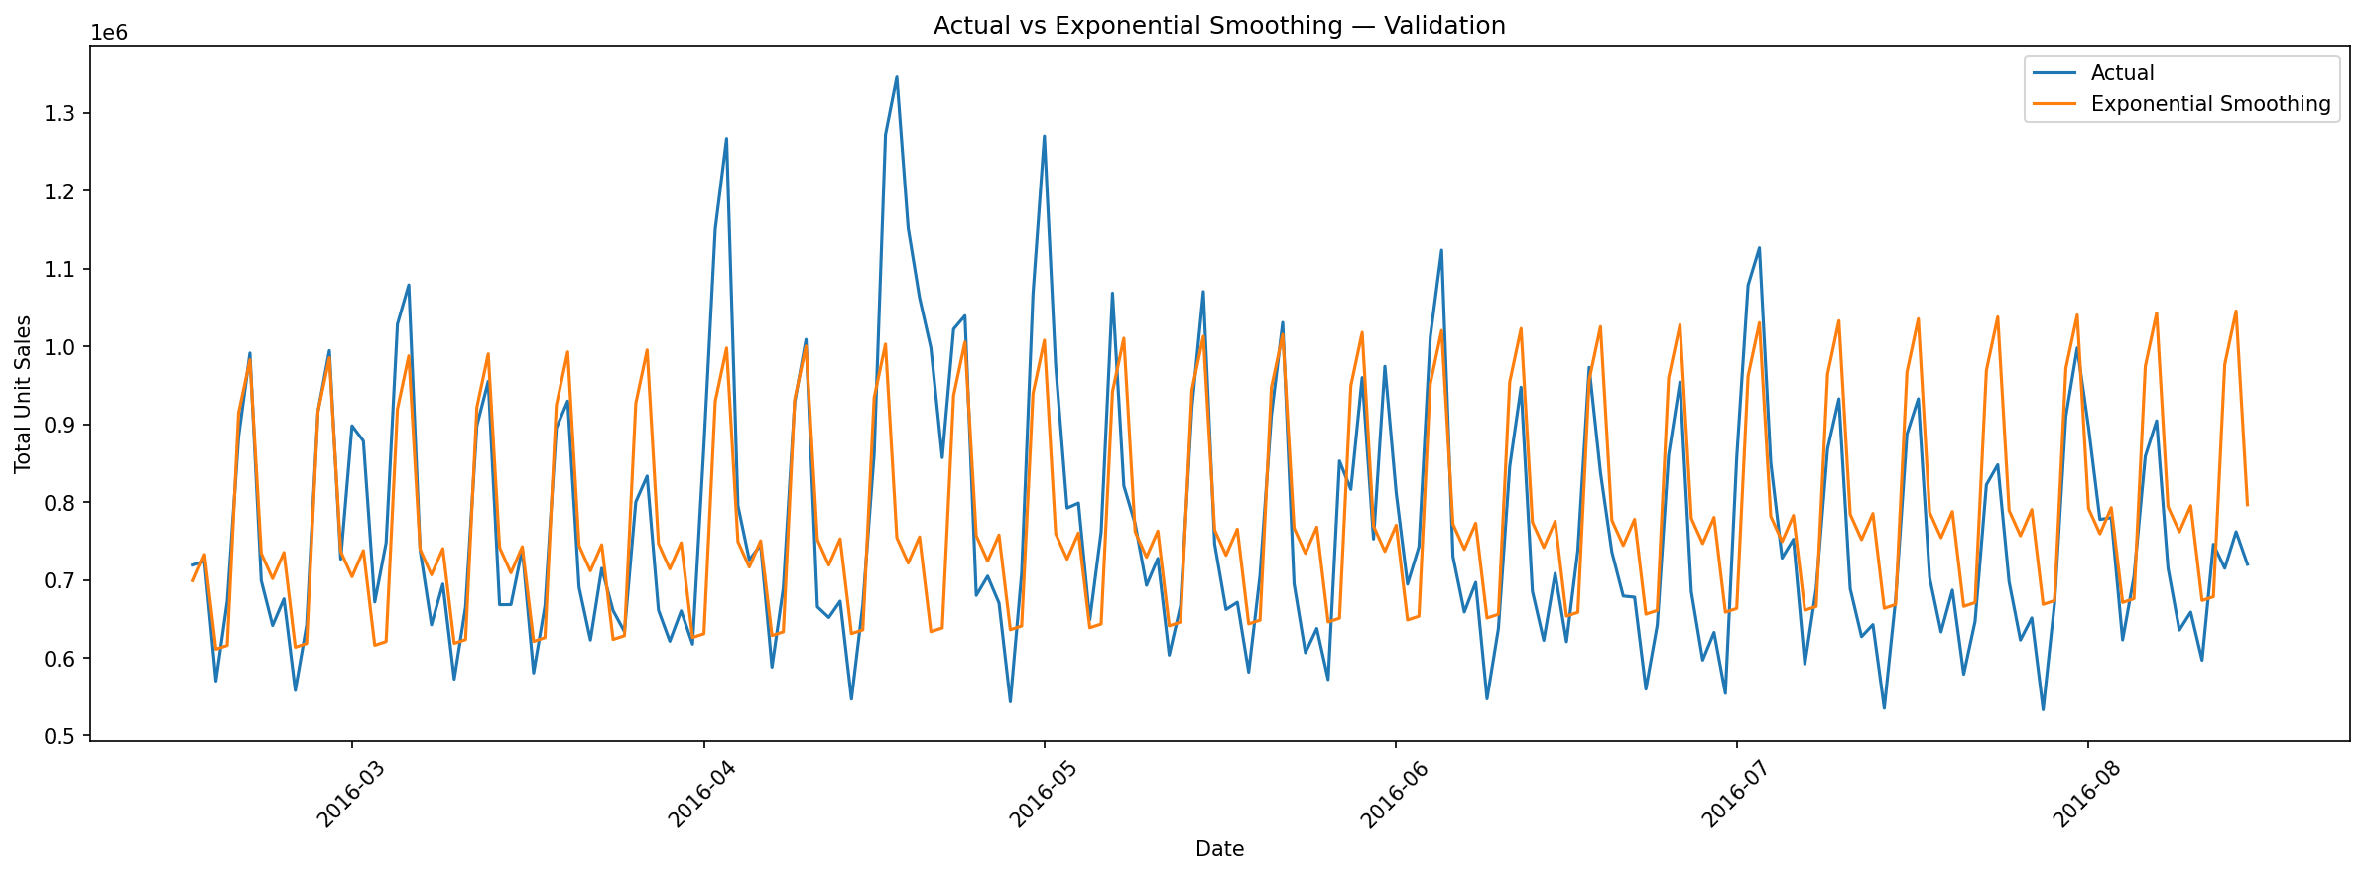
Actual vs Exponential Smoothing — Validation

Validation — Prophet
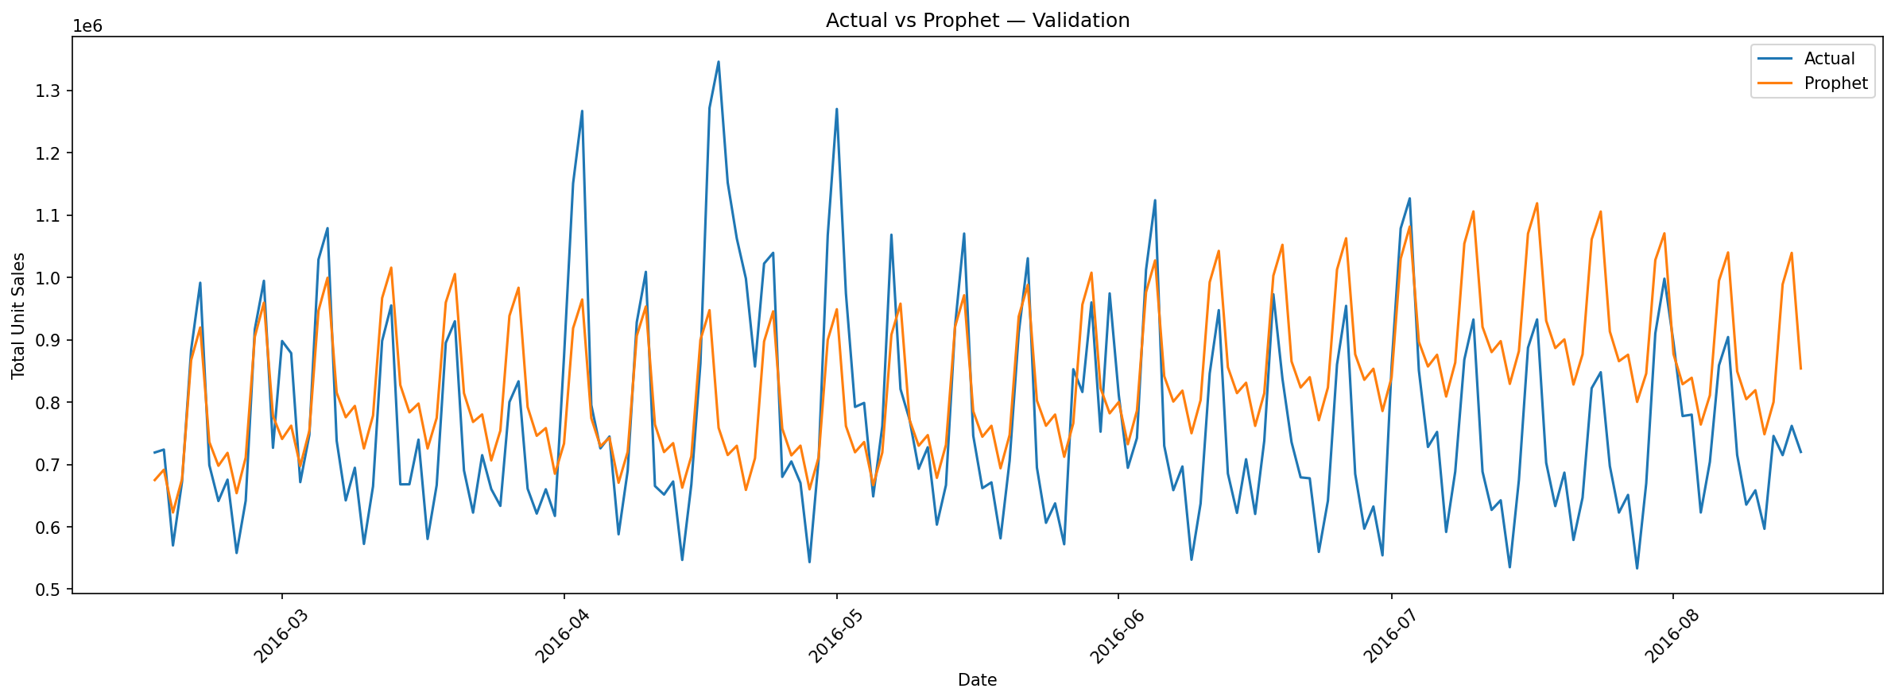
Actual vs Prophet — Validation

Validation — LSTM
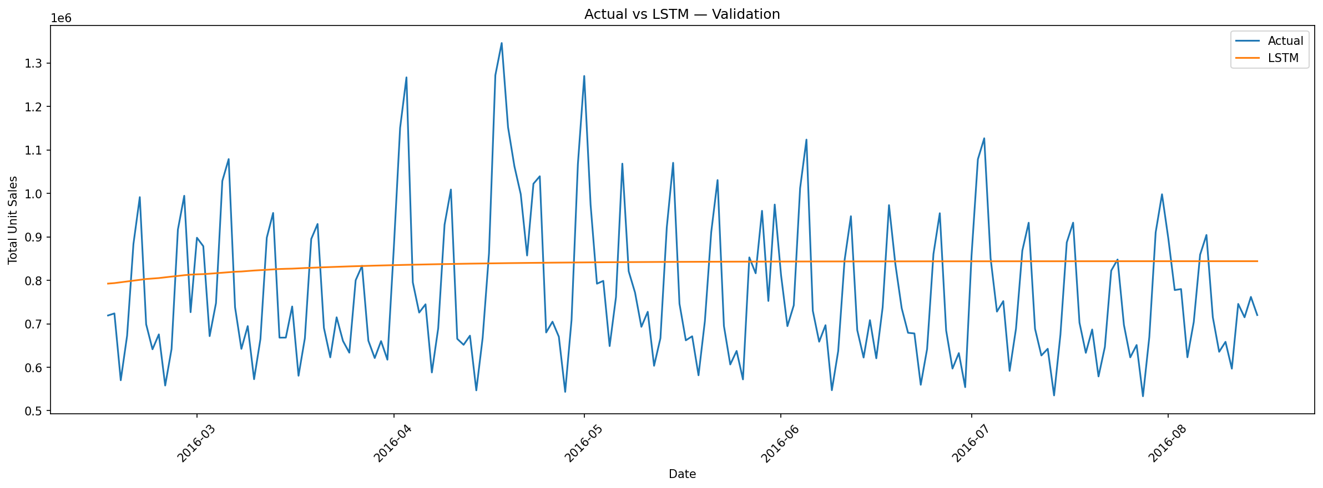
Actual vs LSTM — Validation

Validation — Main Model Comparison
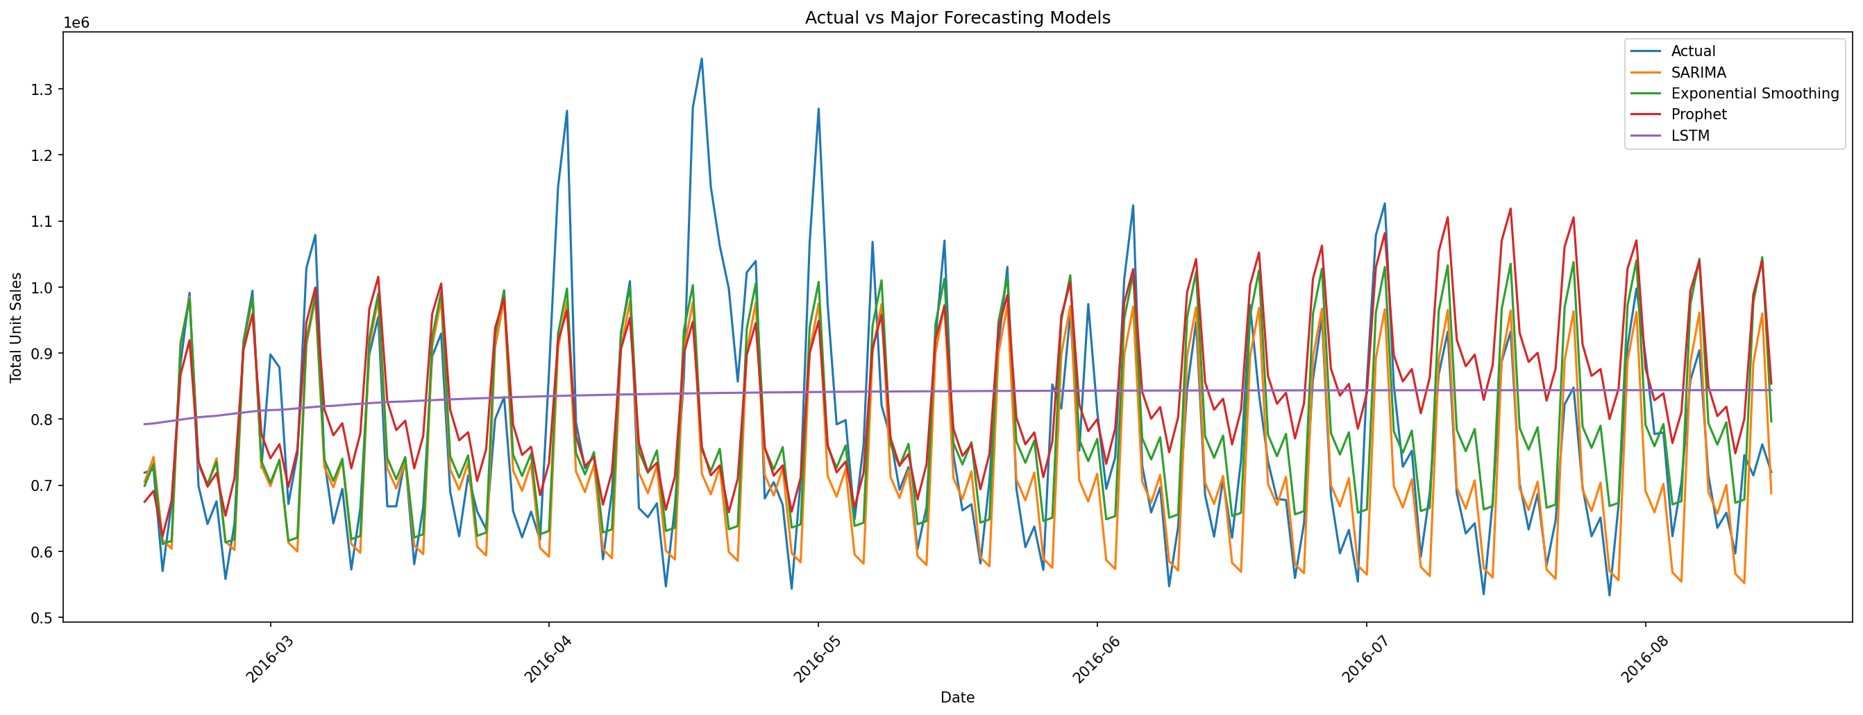
Actual vs SARIMA vs Exponential Smoothing vs Prophet vs LSTM

Final Test — Actual vs Tuned SARIMA
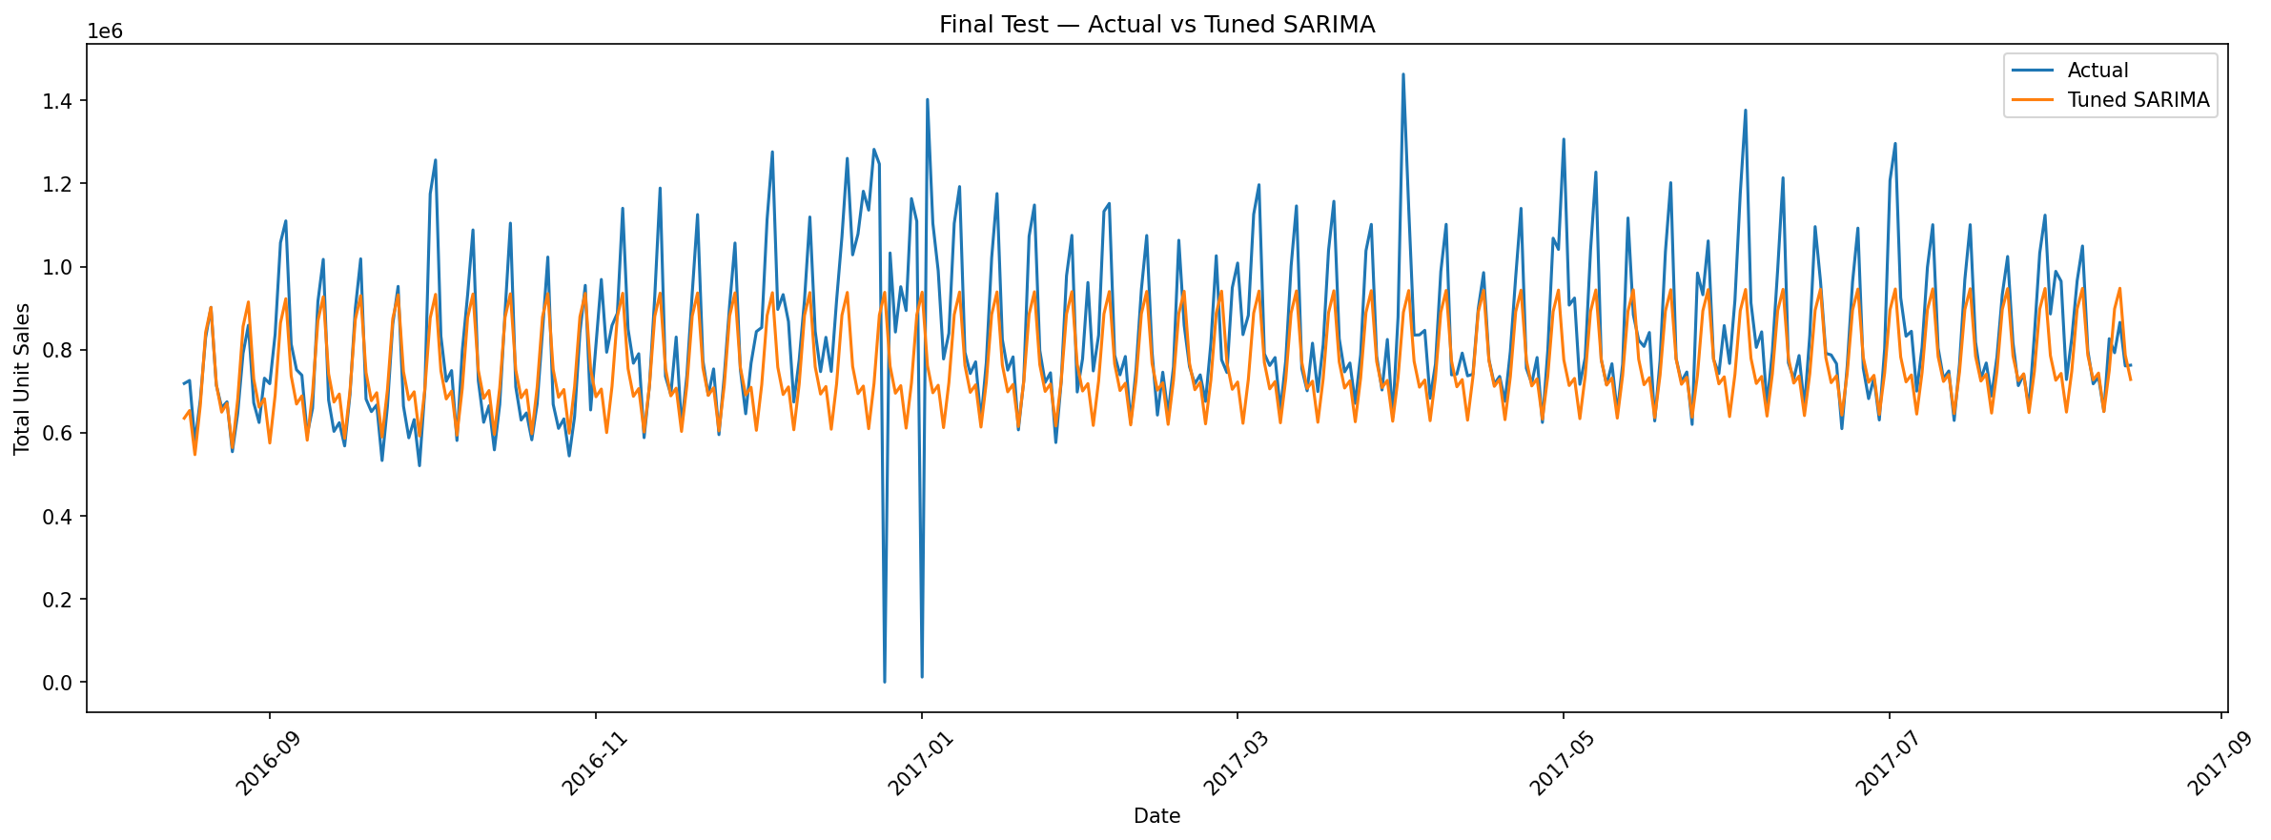
Final Test Actual vs Tuned SARIMA

Final Test — Actual vs Seasonal Naive
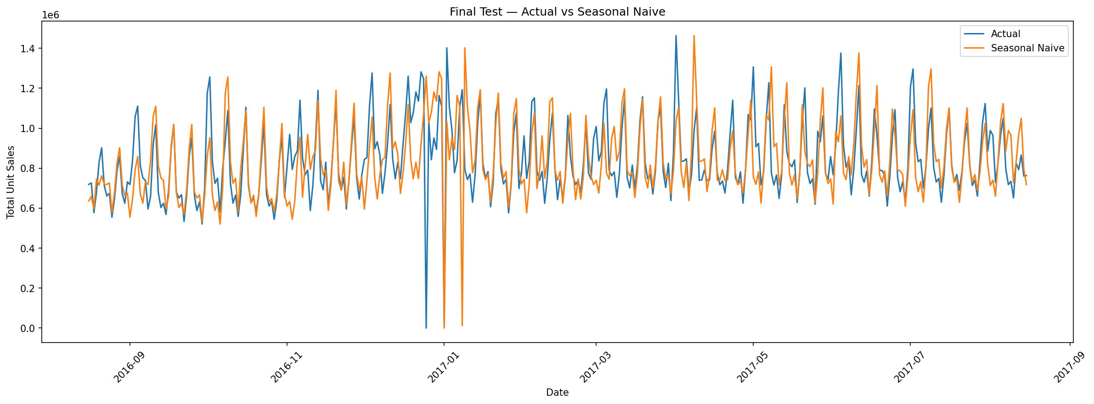
17. Product-Level Accuracy
The product-level analysis evaluated five high-demand products.
Item # | Family | Model | MAE | RMSE | MAPE (%) | Dir. Acc. (%)
364606 | Grocery I | SARIMA | 363.493 | 551.201 | 50.455 | 72.253
364606 | Grocery I | Seasonal Naive | 420.384 | 672.658 | 17.526 | 70.330
819932 | Beverages | SARIMA | 660.520 | 1,005.060 | 38.615 | 67.308
819932 | Beverages | Seasonal Naive | 834.260 | 1,312.870 | 36.741 | 62.088
1047679 | Beverages | Seasonal Naive | 595.912 | 960.802 | 18.057 | 70.604
1047679 | Beverages | SARIMA | 1,321.000 | 1,517.830 | 54.504 | 62.363
1473474 | Produce | Seasonal Naive | 486.625 | 751.623 | 9.992 | 90.934
1473474 | Produce | SARIMA | 1,916.190 | 2,220.780 | 49.772 | 45.055
1503844 | Produce | Seasonal Naive | 946.733 | 1,427.650 | 17.724 | 83.791
1503844 | Produce | SARIMA | 1,681.450 | 2,118.270 | 35.019 | 62.637

Product-Level Model Comparison
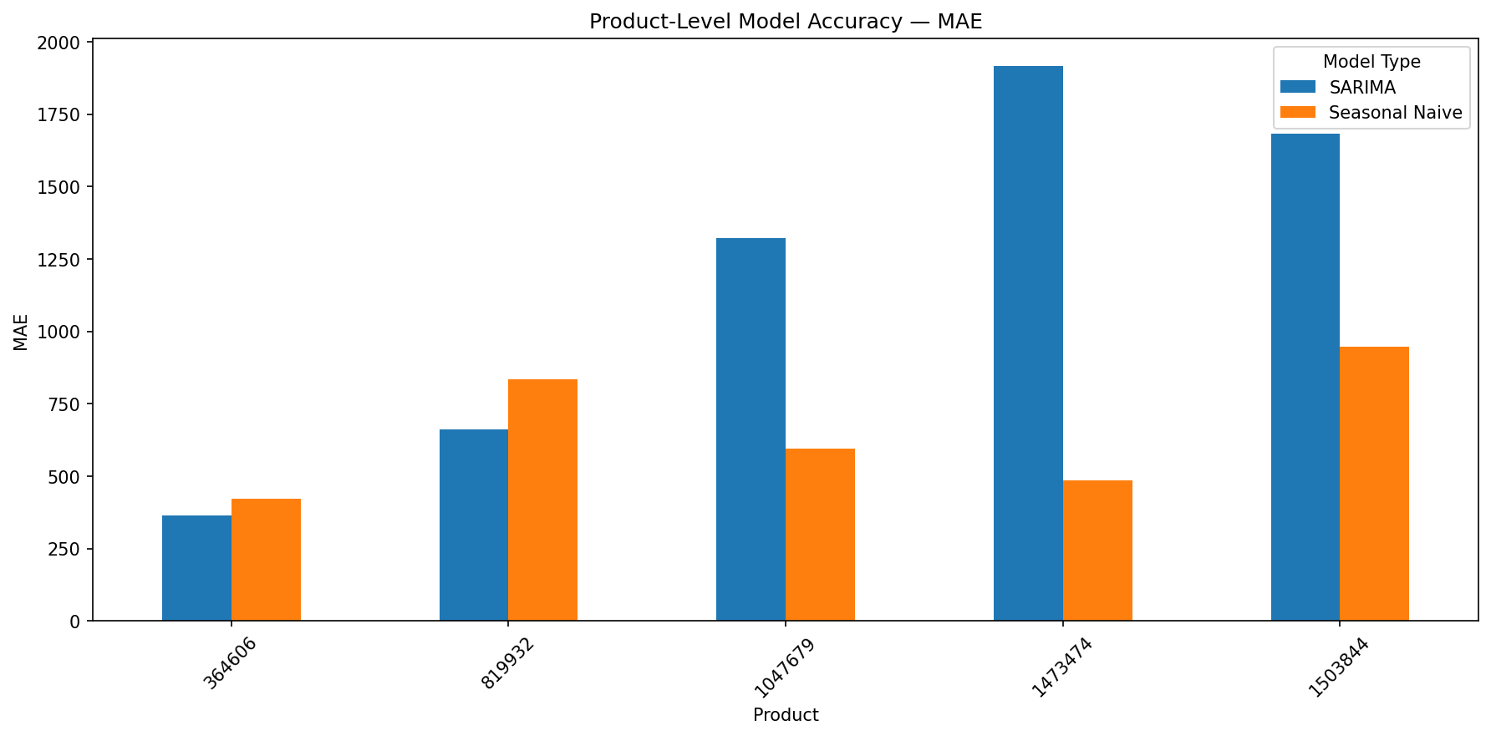

Product-Level Findings
SARIMA achieved lower MAE than Seasonal Naive for 2 of 5 products (win rate: 40.0%). The results show that the best forecasting method can vary by product.
18. Product-Level Actual vs Predicted Plots

Product 1
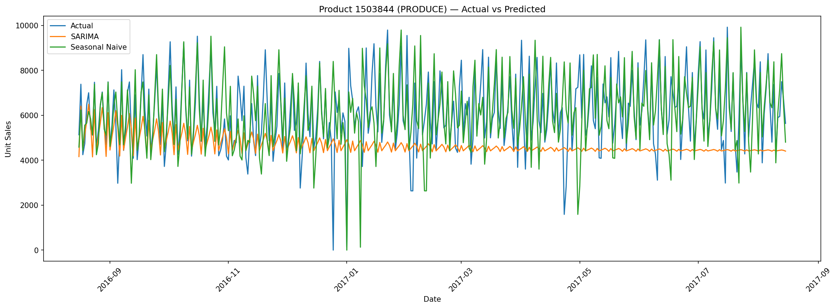
Product 1 — Actual vs Predicted

Product 2
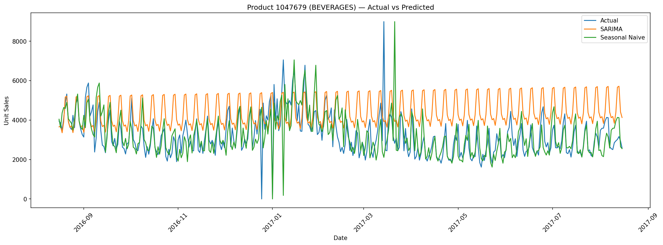
Product 2 — Actual vs Predicted

Product 3
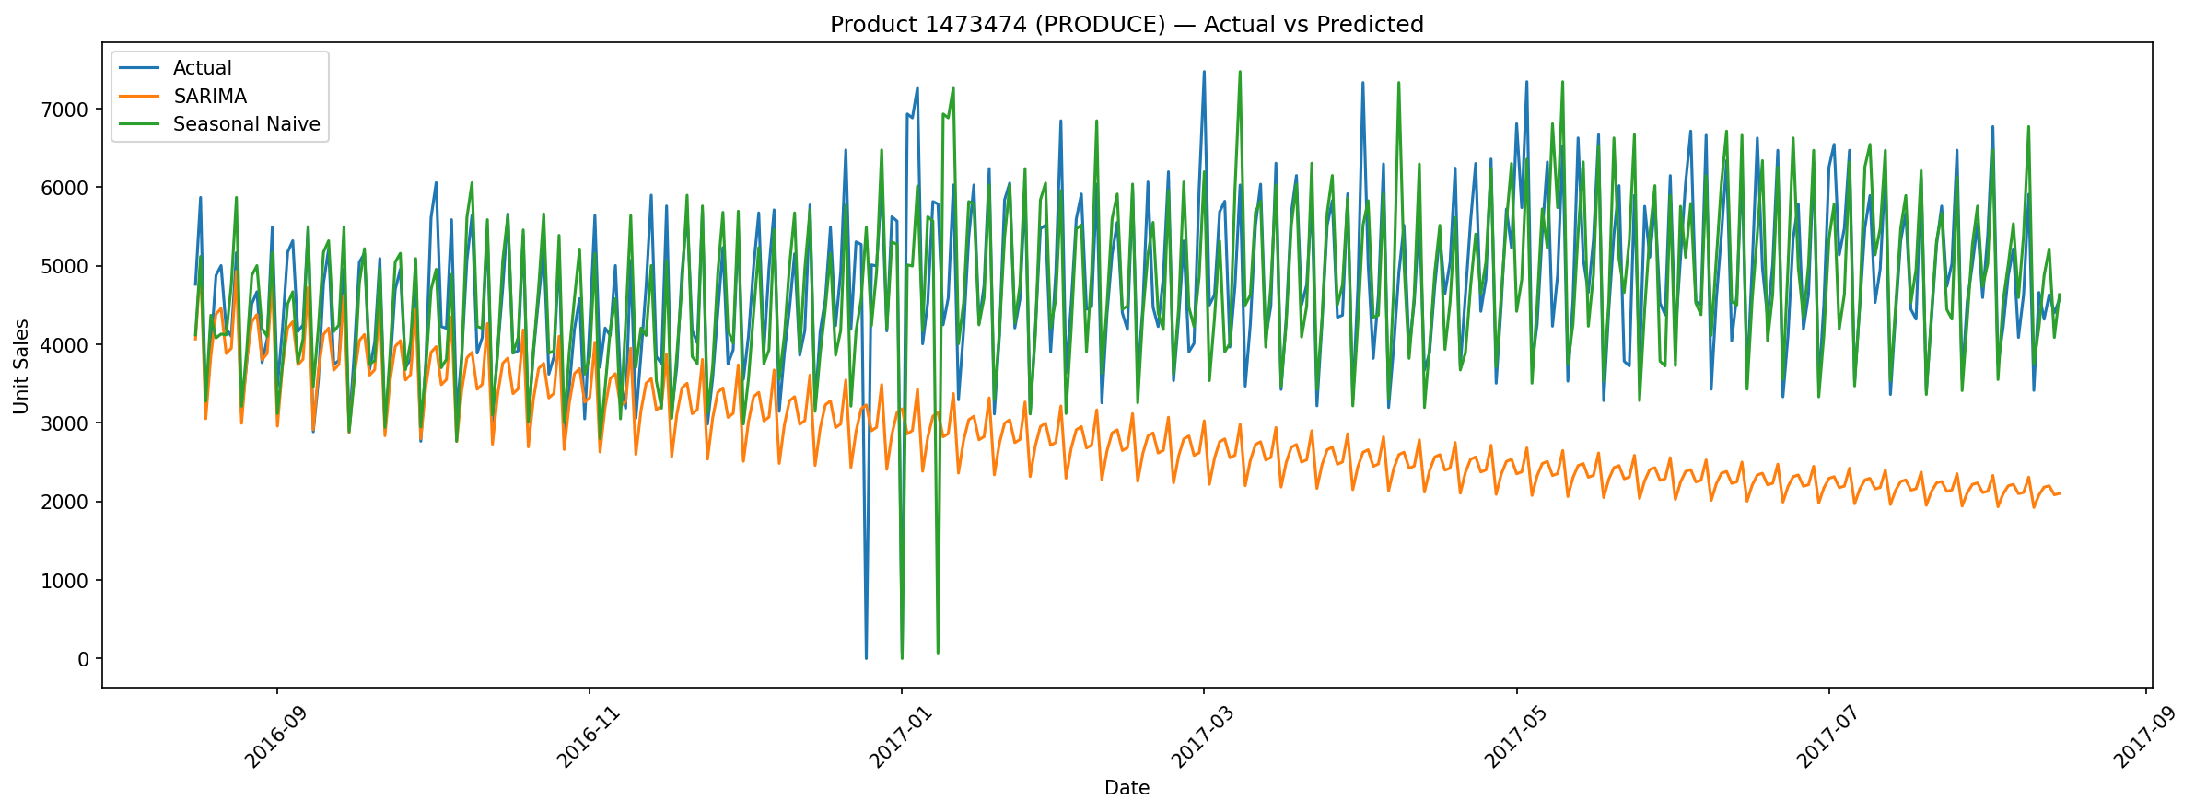
Product 3 — Actual vs Predicted

Product 4
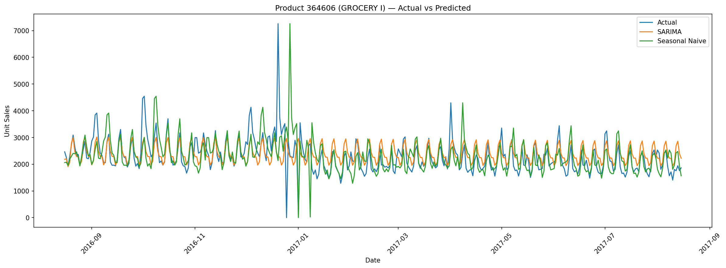
Product 4 — Actual vs Predicted

Product 5
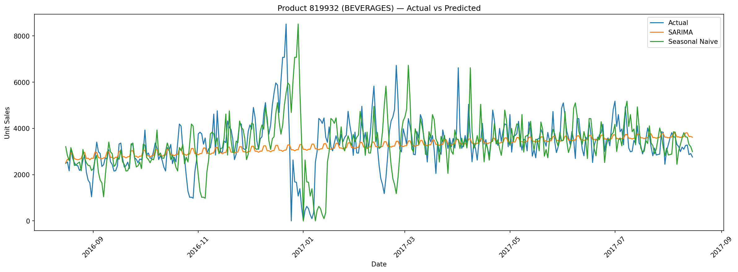
Product 5 — Actual vs Predicted
19. Top Products by Historical Demand
Item # | Historical Sales | Family | Class | Perishable
1503844 | 6,264,200 | Produce | 2022 | Yes
1047679 | 5,512,880 | Beverages | 1120 | No
1473474 | 4,990,320 | Produce | 2014 | Yes
364606 | 4,416,430 | Grocery I | 1014 | No
819932 | 4,410,940 | Beverages | 1122 | No
20. Final 6-Month Forecast
Forecast period: 2017-08-16 to 2018-02-13
Total forecast demand: 141,549,586.18 units
Average daily forecast: 777,744.98 units

21. Final 12-Month Forecast
Forecast period: 2017-08-16 to 2018-08-15
Total forecast demand: 272,158,815.58 units
Average daily forecast: 745,640.59 units
22. Monthly Forecast
Date | Forecast Units | Avg Daily Forecast | Lower 95% | Upper 95%
2017-08-31 | 12,675,700 | 792,229 | 7,930,270 | 17,421,100
2017-09-30 | 24,066,500 | 802,217 | 12,753,900 | 35,379,100
2017-10-31 | 24,533,600 | 791,406 | 9,306,650 | 39,760,500
2017-11-30 | 23,084,700 | 769,489 | 4,793,800 | 41,556,100
2017-12-31 | 24,132,400 | 778,466 | 2,284,510 | 47,377,100
2018-01-31 | 23,273,300 | 750,752 | 490,135 | 51,032,400
2018-02-28 | 20,887,400 | 745,979 | 0 | 50,074,800
2018-03-31 | 22,741,800 | 733,606 | 0 | 59,859,100
2018-04-30 | 21,953,500 | 731,783 | 0 | 62,912,300
2018-05-31 | 21,799,800 | 703,218 | 0 | 69,577,400
2018-06-30 | 21,226,300 | 707,543 | 0 | 72,967,700
2018-07-31 | 21,578,300 | 696,073 | 0 | 80,962,500
2018-08-31 | 10,205,600 | 680,374 | 0 | 41,169,300

Monthly Forecast Plot
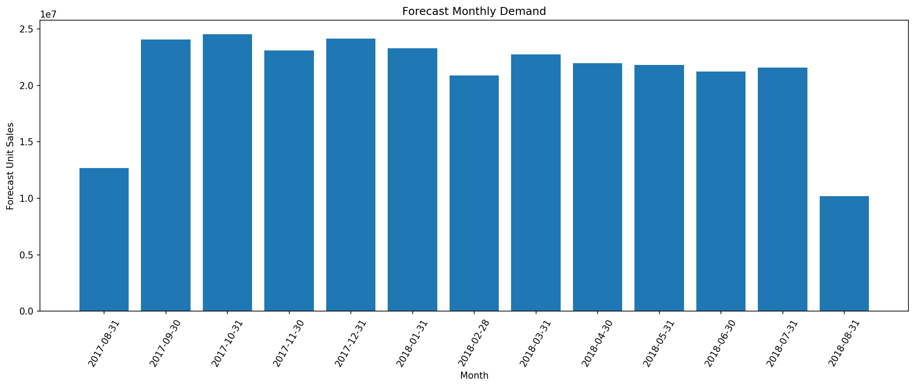
Forecast Monthly Demand

23. Forecast Confidence Intervals
The final SARIMA forecast includes 95% confidence intervals. The intervals become wider as the forecast horizon increases, indicating increased uncertainty for longer-range forecasts.

Forecast Uncertainty
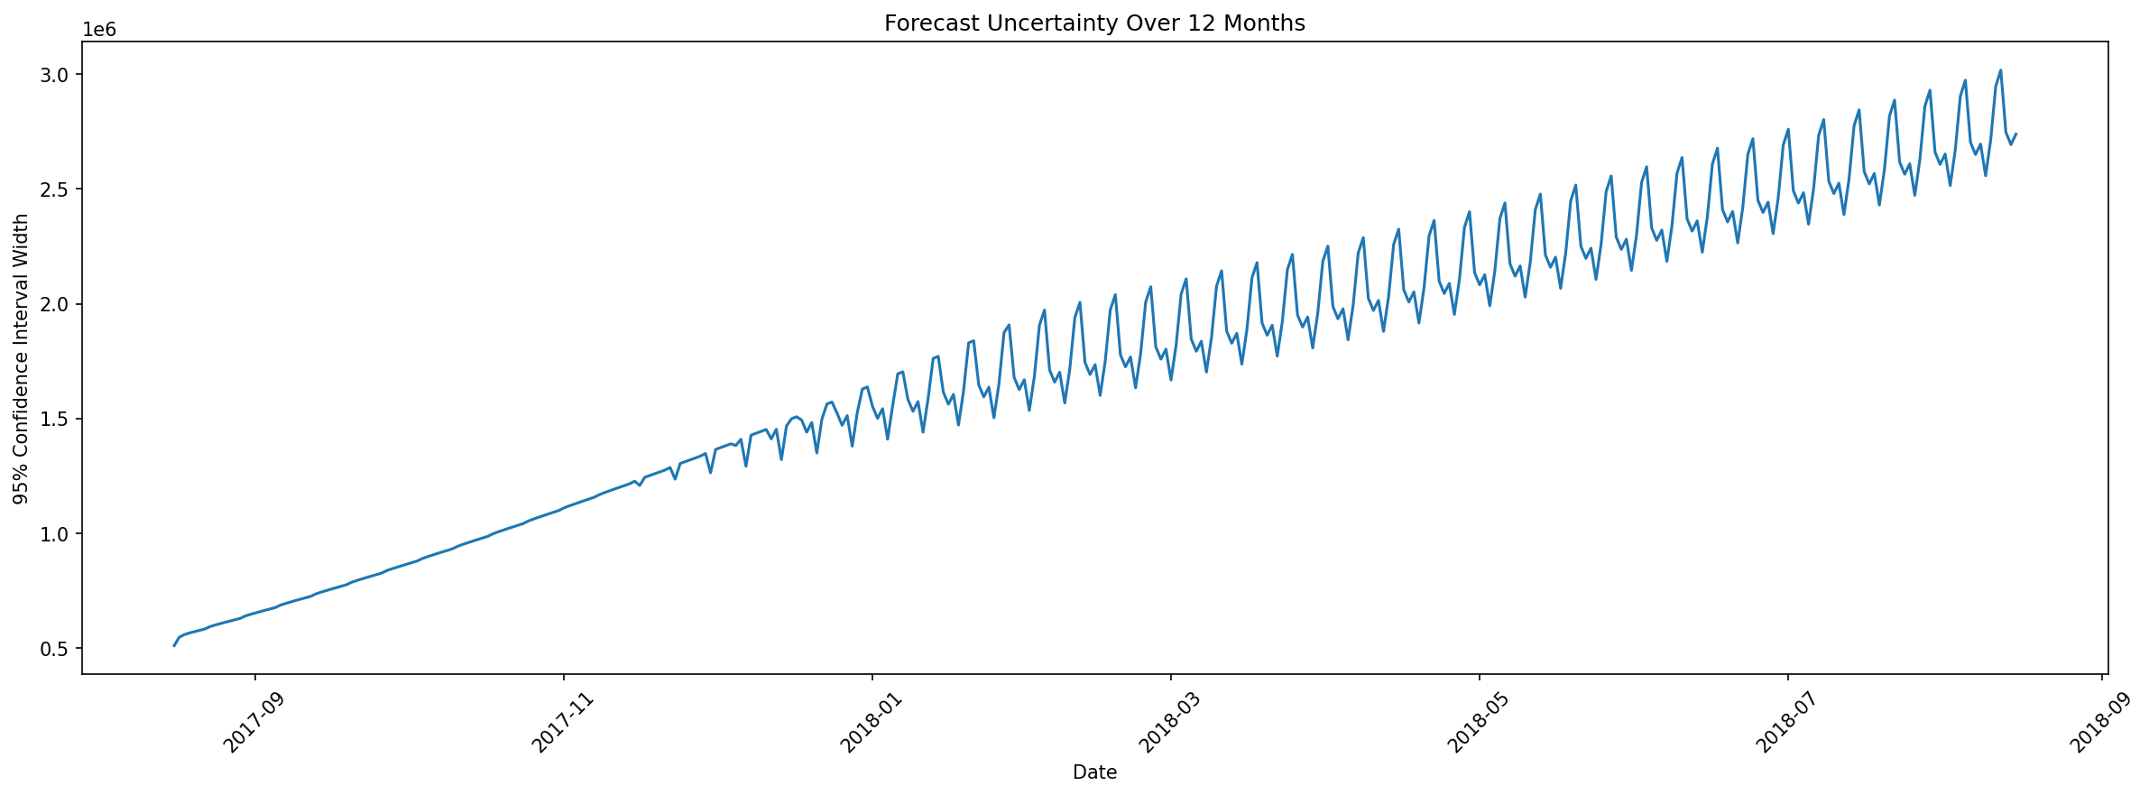
Forecast Uncertainty Over 12 Months
24. Highest and Lowest Forecast-Demand Months

Highest Forecast Month
Date: 2017-10-31
Forecast demand: 24,533,587.20 units

Lowest Forecast Month
Date: 2018-08-31
Forecast demand: 10,205,612.67 units
25. Inventory Planning
Horizon | Days | Expected Demand | Lower Bound | Upper Bound | Safety Buffer | Rec. Stock
7 Days | 7 | 5,666,560 | 3,707,340 | 7,625,780 | 1,959,220 | 7,625,780
14 Days | 14 | 11,301,900 | 7,200,080 | 15,403,800 | 4,101,860 | 15,403,800
30 Days | 30 | 23,886,800 | 14,261,500 | 33,512,100 | 9,625,330 | 33,512,100

Inventory Planning Visualization
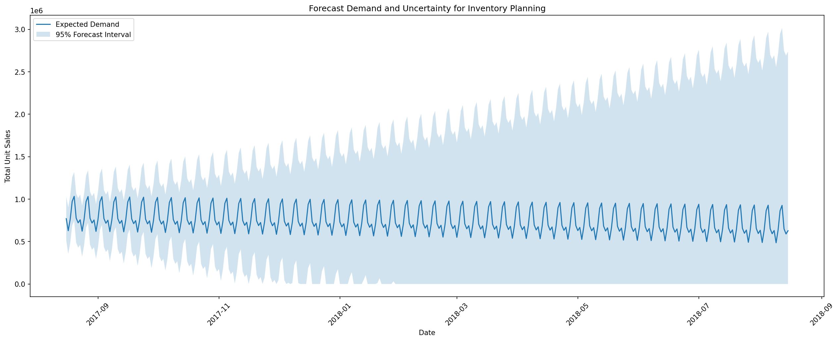
Forecast Demand and Uncertainty for Inventory Planning

26. Business Recommendations

1. Demand Planning
Use the forecasting model as the baseline demand plan and regularly update it as new sales observations become available.

2. Weekly Replenishment
The strong weekly seasonal pattern supports replenishment planning based on day-of-week demand differences.

3. Seasonal Procurement
Procurement and warehouse capacity should be reviewed ahead of higher-demand forecast periods.

4. Safety Stock
The upper forecast confidence bound can be used as a conservative planning scenario when estimating inventory buffers. It should not be treated as guaranteed future demand.

5. Short-Term Replenishment
The 7-day and 14-day demand estimates can support short-term inventory planning when supplier lead times are relatively short.

6. Longer Lead Times
For approximately 30-day supplier lead times, use the 30-day forecast together with the uncertainty buffer.

7. Long-Range Planning
The uncertainty interval becomes wider as the forecast horizon increases. Therefore, long-range decisions should be periodically re-forecast rather than locked in for the full 12 months.

8. Product-Level Planning
Operational inventory decisions should ultimately use product-store-level forecasts rather than only aggregate demand.

9. Model Selection
The final analysis indicates that model selection should consider multiple business metrics. MAE, MAPE, RMSE, and directional accuracy can tell different stories.
27. Project Limitations

Aggregate Forecasting
The primary SARIMA experiment forecasts total aggregate demand, not every product-store combination independently.

Product-Level Coverage
Product-level evaluation was performed on five high-demand products rather than all 4,100 products.

External Variables
The final SARIMA model did not directly incorporate every available external variable such as promotion status, oil prices, store characteristics, and detailed holiday effects.

Product-Level Missingness Assumption
When creating complete daily product-level series, unrecorded product/date observations were represented as zero sales. This is a modeling assumption and should be documented when interpreting those results.

Long-Term Forecast Uncertainty
Confidence intervals widen substantially farther into the future. Therefore, the 12-month forecast should be interpreted as a planning estimate rather than a precise prediction.
28. Recommended Future Improvements
Future versions of the project can improve accuracy by:
- Forecasting at Store × Product level.
- Adding promotion features.
- Adding oil-price variables.
- Incorporating detailed holiday/event variables.
- Using lag and rolling-demand features.
- Testing gradient boosting models.
- Using multivariate LSTM models.
- Testing LightGBM/XGBoost-style demand models.
- Performing hierarchical forecasting across product and store levels.
- Automating periodic reforecasting.
29. Final Conclusion
This project developed a complete time-series forecasting pipeline for the Favorita grocery sales dataset. The workflow included:
Data ingestion → Data cleaning → Exploratory Data Analysis → Trend and seasonality analysis → Time-based feature engineering → Stationarity testing → Differencing → ACF/PACF analysis → Baseline forecasting → ARIMA → SARIMA → Exponential Smoothing → Prophet → LSTM → Hyperparameter tuning → Historical backtesting → Final test evaluation → 6-month forecasting → 12-month forecasting → Confidence intervals → Product-level accuracy → Inventory planning.
The aggregate analysis identified strong weekly seasonality and substantial changes in demand over time. The tuned SARIMA model achieved:
- Test MAE: 102,726.91
- Test RMSE: 159,075.85
- Test MAPE: 31.36%
- Test Directional Accuracy: 79.95%

The final forecasting period covers approximately 6–12 months after the end of the historical data. These forecasts and their uncertainty intervals can support aggregate demand planning, inventory buffering, replenishment planning, and seasonal supply-chain preparation.
30. Deliverables Checklist
Deliverable | Status
Jupyter Notebook | Completed — export notebook separately
Model Comparison Report | Included in this report
Actual vs Predicted Visualizations | Included
Accuracy Metrics by Product | Included
Business Recommendations | Included
Confidence Interval Plots | Included
6-Month Forecast | Included
12-Month Forecast | Included
Backtesting | Included
Hyperparameter Tuning | Included
Stationarity Analysis | Included
ACF/PACF Analysis | Included

31. Generated Project Files
The notebook / exported project should include the following outputs:
- daily_sales_features.csv
- final_forecasting_dataset.csv
- train_timeseries.csv
- validation_timeseries.csv
- test_timeseries.csv
- baseline_results.csv
- arima_results.csv
- sarima_results.csv
- exponential_smoothing_results.csv
- prophet_results.csv
- lstm_results.csv
- sarima_tuning_results.csv
- backtest_results.csv
- pooled_backtest_results.csv
- final_test_results.csv
- top_5_products.csv
- product_level_accuracy.csv
- final_6_month_forecast.csv
- final_12_month_forecast.csv
- monthly_forecast_summary.csv
- final_inventory_planning.csv
END OF REPORT

